**Airport Management System**

**Requirement Specifications**  
March 11, 2025  
—  
Airport Operations & Management Team  
—  


**Table of Contents**

1. **Executive Summary**
   1. Project Overview ...... 3
   2. Product/Service Description ...... 4

1.Airport Management System (AMS) ...... 4

* + - 1. Product Context ...... 4
      2. User Characteristics ...... 4
    1. Passenger Experience System (PES) ...... 5
       1. Product Context ...... 5
       2. User Characteristics ...... 5
  1. Assumptions ...... 6
  2. Constraints and Dependencies ...... 6

1. **Requirements**
   1. Airport Management System (AMS) ...... 7
      1. Functional Requirements ...... 7
      2. Non-Functional Requirements ...... 10
         1. Product Requirements ...... 10
         2. Organizational Requirements ...... 10
         3. External Requirements ...... 10
   2. Passenger Experience System (PES) ...... 11
      1. Functional Requirements ...... 11
      2. Non-Functional Requirements ...... 15
         1. Product Requirements ...... 15
         2. Organizational Requirements ...... 15
         3. External Requirements ...... 15
   3. Non-Functional Requirements for Both Systems ...... 16

**Project Overview**

Our vision is to develop an **airport-centric system** designed to streamline airport operations while enhancing the passenger experience. This system will encompass two integrated software solutions: one dedicated to the internal management of airport operations and the other tailored to improving the passenger journey. These software applications will be offered as a comprehensive package. Airports that adopt this system will provide their staff and passengers with full access to both platforms. However, individuals not affiliated with the airport (e.g., external vendors) will have limited access to specific features.

**Airport Management System (AMS)**

**Product Context**

The first software is for the internal management of airport operations. This system is designed for airports worldwide to manage flights, baggage, security, and other critical operations.

**The *stakeholders* of this system include:**

* Airport Operations Staff
* Air Traffic Control
* Security Personnel
* Baggage Handling Teams
* Airlines
* Ground Handling Services
* Maintenance Teams
* Payroll and HR Department
* Procurement Office
* Cargo Services
* Control Office
* First Aid Teams

**User Characteristics:**

* **Airport Operations Staff** manage flight schedules, gate assignments, and runway usage.
* **Air Traffic Control** monitors and directs aircraft movements in real-time.
* **Security Personnel** oversee passenger and baggage screening processes.
* **Baggage Handling Teams** track and manage luggage from check-in to loading onto aircraft.
* **Airlines** manage flight manifests, crew schedules, and passenger boarding.
* **Ground Handling Services** coordinate aircraft refueling, catering, and cleaning.
* **Maintenance Teams** ensure airport facilities and equipment are operational and safe.
* **Payroll and HR Department** manage employee salaries, benefits, and administrative tasks.
* **Procurement Office** handles the procurement of items needed for aircraft maintenance and repairs.
* **Cargo Services** manage the transportation and tracking of cargo shipments.
* **Control Office** oversees overall airport operations and ensures compliance with regulations.
* **First Aid Teams** provide medical assistance to passengers and staff in emergencies.

**Passenger Experience System (PES)**

**Product Context**

This system is designed to enhance the passenger experience by providing real-time information, self-service options, and personalized services.

**The *stakeholders* of this system include:**

* Passengers
* Airlines
* Airport Retailers
* Security Personnel
* Customer Service Teams
* IT Support Teams

**User Characteristics:**

* **Passengers** can check flight status, access boarding passes, receive real-time updates, and use self-service kiosks for check-in and baggage drop.
* **Airlines** provide flight information, manage boarding processes, and handle passenger requests.
* **Airport Retailers** offer promotions and manage inventory through the system.
* **Security Personnel** verify passenger identities and manage security checkpoints.
* **Customer Service Teams** assist passengers with inquiries and issues.
* **IT Support Teams** ensure the system is operational and troubleshoot technical issues.

**Assumptions**

1. The system will integrate with existing airport infrastructure, including flight information displays, baggage handling systems, and security systems.
2. All users will have access to the necessary hardware (e.g., kiosks, scanners) to interact with the system.
3. The system will comply with international aviation regulations and standards.

**Constraints and Dependencies**

**Constraints:**

1. **Scalability:** The system must handle a growing number of flights, passengers, and data without performance degradation.
2. **Budgetary Limitations:** The cost of development, deployment, and maintenance must align with the airport's financial resources.
3. **Interoperability:** Compatibility with existing airport systems (e.g., baggage handling, flight scheduling).

**Dependencies:**

1. **Technological Infrastructure:** Reliable servers, databases, and network connectivity to support the system.
2. **Stakeholder Input:** Collaboration with airport staff, airlines, and passengers to ensure the system meets their needs.
3. **Regulatory Compliance:** Dependence on aviation authorities to ensure the system meets all legal and safety requirements.
4. **Maintenance and Support:** Ongoing technical support and updates to address bugs and improve functionality.

**Requirements - Airport Management System (AMS)**

**Functional Requirements**

**1. Flight Scheduling and Management**

1. **Airport Operations Staff** create and update flight schedules, including departure and arrival times, gate assignments, and runway usage.
2. **Air Traffic Control** monitors and directs aircraft movements in real-time.
3. **System** automatically updates flight statuses and notifies relevant stakeholders of any changes.

**2. Baggage Handling and Tracking**

1. **Baggage Handling Teams** track luggage from check-in to loading onto aircraft.
2. **System** provides real-time updates on baggage location and status.
3. **Passengers** receive notifications if their baggage is delayed or misplaced.

**3. Security and Screening**

1. **Security Personnel** manage passenger and baggage screening processes.
2. **System** integrates with security scanners and provides real-time alerts for suspicious items.
3. **Passengers** are notified of security wait times and checkpoint statuses.

**4. Maintenance and Facility Management**

1. **Maintenance Teams** log and track maintenance requests for airport facilities and equipment.
2. **System** schedules and prioritizes maintenance tasks based on urgency.
3. **Airport Operations Staff** receive notifications when maintenance is completed.

**5. Salary Calculation and Payroll Management**

1. **Payroll and HR Department** calculate employee salaries based on hours worked, overtime, and benefits.
2. **System** automatically generates payroll reports and processes payments.
3. **Employees** can access their salary details and payment history through the system.

**6. Procurement of Items for Aircraft Maintenance**

1. **Procurement Office** identifies and procures items needed for aircraft repairs and maintenance.
2. **System** tracks inventory levels and automatically generates purchase orders when stock is low.
3. **Maintenance Teams** receive notifications when procured items are available for use.

**7. Cargo Services Management**

1. **Cargo Services** manage the transportation and tracking of cargo shipments.
2. **System** provides real-time updates on cargo location and status.
3. **Airlines** and **Customers** receive notifications about cargo delivery status.

**8. First Aid Services**

1. **First Aid Teams** provide medical assistance to passengers and staff in emergencies.
2. **System** tracks medical supplies and generates alerts when restocking is needed.
3. **Passengers** can request first aid assistance through the system.

*or the Airport Management System (AMS):*

1. **Runway Utilization Optimization**  
   Automatically optimize runway assignments based on real-time flight data to maximize efficiency.
2. **Emergency Response Coordination**  
   Integrate a module for dispatching emergency services, alerting appropriate teams, and tracking incident resolutions.
3. **Airport Facility Inventory Management**  
   Monitor and manage supplies and spare parts for airport operations with automated restocking alerts.
4. **Weather Data Integration**  
   Incorporate weather data feeds to inform flight scheduling adjustments and enhance safety protocols.
5. **Ground Transportation Coordination**  
   Manage shuttle buses and ground transport logistics for staff and passengers, ensuring timely pickups and drop-offs.
6. **Vendor and Contractor Management**  
   Allow for the management of external service providers (e.g., cleaning, catering) with contract tracking and performance metrics.
7. **Environmental Monitoring**  
   Track noise levels, air quality, and emissions in real time to ensure compliance with environmental standards.
8. **Energy Management System Integration**  
   Monitor and control energy usage (lighting, HVAC) across terminals to improve operational efficiency.
9. **Flight Delay and Disruption Management**  
   Automatically detect and manage delays, providing alternative scheduling options and notifications to stakeholders.
10. **Digital Signage and Passenger Notification System**  
    Control dynamic displays across the airport to broadcast real-time updates and alerts.

**Requirements - Passenger Experience System (PES)**

**Functional Requirements**

**1. Flight Information and Updates**

1. **Passengers** can check real-time flight status, gate information, and boarding times.
2. **System** sends automated notifications for flight delays, cancellations, and gate changes.

**2. Self-Service Options**

1. **Passengers** can check-in, print boarding passes, and drop baggage at self-service kiosks.
2. **System** integrates with airline systems to ensure accurate passenger information.

**3. Retail and Dining Services**

1. **Airport Retailers** offer promotions and manage inventory through the system.
2. **Passengers** can browse and purchase items from airport retailers via the system.

**4.**  **Self-Service Baggage Drop and Tag Printing**  
Extend self-service kiosks to include baggage tagging and drop-off functionalities, reducing wait times.

**5.**  **Personalized Passenger Itinerary and Travel Assistance**  
Offer personalized itineraries that integrate flight, transfer, and ancillary service details for a streamlined travel experience.

**6.**  **Interactive Wayfinding and Terminal Navigation**  
Provide interactive maps and navigation assistance to help passengers locate gates, lounges, and other services.

**7.**  **Real-Time Passenger Feedback Collection**  
Incorporate feedback tools that allow passengers to rate services and report issues instantly, with results used for continuous improvement.

**8.**  **Digital Advertisement and Promotion Display System**  
Enable targeted advertising and promotional content display based on passenger profiles and real-time context.

**9.**  **Lost and Found Reporting System**  
Allow passengers to report lost items, track status, and receive updates through a dedicated module.

**10.**  **Special Assistance Request Handling**  
Provide an interface for passengers requiring special assistance (e.g., mobility support) to request help promptly.

**11.**  **Lounge and Facility Reservation System**  
Allow premium passengers to reserve lounge access or other airport facilities directly from the system.

**Non-Functional Requirements**

**Product Requirements**

1. **Usability:** The system must have an intuitive interface for both airport staff and passengers.
2. **Performance:** The system must handle up to 10,000 concurrent users during peak times without delays or crashes.
3. **Security:** Sensitive information, such as passenger data and flight manifests, must be encrypted both at rest and in transit.

**Organizational Requirements**

1. **Compliance:** The system must comply with international aviation regulations and standards.
2. **Uptime:** The system must guarantee 99.9% uptime, with automated backup and disaster recovery mechanisms.

**External Requirements**

1. **Global Accessibility:** The system must ensure 24/7 availability for passengers and staff worldwide.
2. **Regulatory Compliance:** The system must adhere to all legal and safety requirements set by aviation authorities.

**Non-Functional Requirements for Both Systems**

1. **Scalability:** Both systems must support a growing number of users, flights, and data without performance degradation.
2. **Interoperability:** Both systems must integrate seamlessly with existing airport infrastructure and third-party systems.
3. **Security:** Both systems must implement multi-factor authentication and encryption to protect sensitive data.

### **Clarification on How They Apply to AMS and PES:**

1. **Usability** → Applies to both AMS and PES
   * AMS: Airport staff must easily navigate and use the system.
   * PES: Passengers need a user-friendly interface for self-service.
2. **Performance** → Applies to both AMS and PES
   * AMS: Handles high traffic from operations and airport personnel.
   * PES: Manages thousands of passengers using self-service options simultaneously.
3. **Scalability** → Applies to both AMS and PES
   * Both systems must scale as airport traffic increases.
4. **Reliability (99.9% uptime)** → Applies to both
   * Critical for AMS to ensure smooth airport operations.
   * Essential for PES to prevent disruptions in passenger services.
5. **Security (Multi-Factor Authentication, Encryption)** → Applies to both
   * AMS: Protects sensitive operational data (e.g., flight schedules, payroll).
   * PES: Secures passenger personal information (e.g., boarding passes, payment details).
6. **Compliance (Aviation and Data Protection Laws)** → Applies to both
   * AMS: Must comply with **IATA, ICAO, and aviation safety regulations**.
   * PES: Must comply with **GDPR and passenger data privacy laws**.
7. **Interoperability (Integration with Existing Systems)** → Applies to both
   * AMS: Must integrate with flight management, baggage handling, and security systems.
   * PES: Needs to sync with airline databases, ticketing systems, and self-service kiosks.
8. **Maintainability (Modular Architecture, Frequent Updates)** → Applies to both
   * Both systems require frequent updates and maintenance with minimal downtime.
9. **Accessibility (For Airport Staff & Passengers with Disabilities)** → Applies to both
   * AMS: Ensures accessibility for employees with disabilities.
   * PES: Supports screen readers, multiple languages, and easy navigation for travelers.
10. **Localization (Multi-language Support)** → More relevant for PES
    * AMS: Could be localized for staff across different countries.
    * PES: Passengers from multiple nationalities need language options.
11. **Availability (24/7 Real-time Updates)** → Applies to both
    * AMS: Must be available at all times for airport personnel.
    * PES: Passengers need real-time updates about flights and services.
12. **Data Integrity (Accurate Information Across Systems)** → Applies to both
    * AMS: Ensures flight data, baggage tracking, and financial records are correct.
    * PES: Ensures flight schedules, check-in details, and passenger information remain accurate.
13. **Disaster Recovery (Backup & System Restoration in Case of Failure)** → Applies to both
    * AMS: Must restore operational data quickly after system failures.
    * PES: Ensures passengers can still check flight details and boarding passes in case of downtime.
14. **Environmental Efficiency (Optimize Energy Consumption & Reduce Waste)** → Applies to AMS
    * AMS: Manages energy use in terminals, baggage handling, and runway lighting.
15. **Responsiveness (Fast Load Times & Performance Optimization)** → Applies to both
    * AMS: Must quickly process flight and baggage data.
    * PES: Should load check-in pages, flight updates, and self-service kiosks without delay.
16. **Error Handling (Detect & Recover from System Failures)** → Applies to both
    * Both systems should log errors and recover automatically from common failures.
17. **Auditability (Track & Monitor System Usage and Changes)** → Applies to both
    * AMS: Logs operational changes for security and accountability.
    * PES: Keeps a record of transactions, complaints, and system usage for review.
18. **Industry Standard Compliance (IATA, ICAO, GDPR, etc.)** → Applies to both
    * Both systems must comply with relevant aviation and data privacy regulations.
19. **Network Resilience (Handle Connectivity Issues Gracefully)** → Applies to both
    * AMS: Must continue working during temporary network failures.
    * PES: Should still provide flight information and boarding passes offline when necessary.
20. **User Training & Support (Guides, Documentation, & Customer Assistance)** → Applies to both
    * AMS: Staff training for system usage, error handling, and troubleshooting.
    * PES: Self-help documentation and customer service options for passengers.

**General Description in Detail**

The **Airport Management System (AMS)** and **Passenger Experience System (PES)** are designed to work in tandem to ensure efficient airport operations and a seamless passenger experience. The AMS focuses on internal operations, including flight scheduling, baggage handling, security, maintenance, payroll, procurement, cargo services, and first aid. The PES enhances the passenger journey by providing real-time flight information, self-service options, and retail services. Both systems are scalable, secure, and compliant with international aviation standards, ensuring smooth operations and a positive experience for all stakeholders.

**Use case diagrams for the Functional Requirements**

**

**

**

**

**

**

**

**

**

**10,11.** 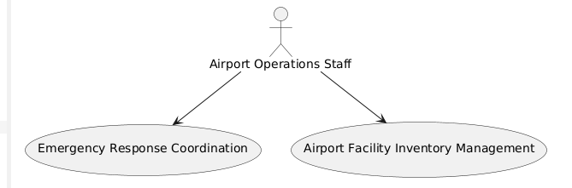

**

**

**

**

**

**

**

**

**

**

**

Below is a comprehensive set of tables that explain each use case diagram drawn from the functional requirements detailed in the document. For clarity, the use cases are grouped into two systems: the Airport Management System (AMS) and the Passenger Experience System (PES). Note that the original file numbers the diagrams from 1 to 30 (with some grouped together), so the tables below map the requirements accordingly.

**Airport Management System (AMS)**

**Use Case 1: Flight Scheduling and Management**

| **Use Case** | **Flight Scheduling and Management** |
| --- | --- |
| **Actors** | Airport Operations Staff, Air Traffic Control |
| **Description** | Create and update flight schedules—including departure/arrival times, gate assignments, and runway usage—with real‐time updates. |
| **Preconditions** | Flight data is available and the system is online. |
| **Main Flow** | 1. Operations staff enter flight details.2. Air Traffic Control reviews and confirms the schedule.3. The system updates and broadcasts changes. |
| **Alternate Flows** | If a flight is delayed, the system recalculates assignments and notifies stakeholders. |
| **Postconditions** | Updated schedules are communicated to all relevant parties. |

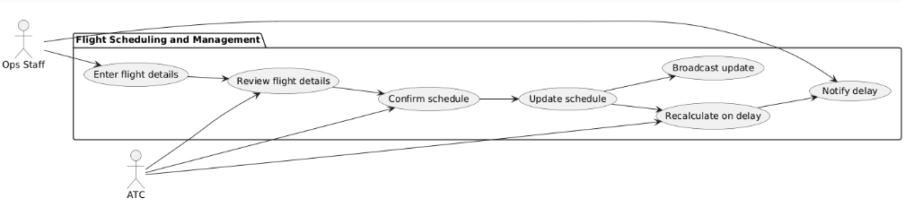

**Use Case 2: Baggage Handling and Tracking**

| **Use Case** | **Baggage Handling and Tracking** |
| --- | --- |
| **Actors** | Baggage Handling Teams, Passengers |
| **Description** | Track baggage from check-in through loading, providing real‑time status updates to both staff and passengers. |
| **Preconditions** | Baggage tags are issued and the tracking system is active. |
| **Main Flow** | 1. Baggage is checked in and tagged.2. Handling teams scan and sort baggage.3. The system updates the baggage location in real time. |
| **Alternate Flows** | If a bag is misplaced, the system triggers a notification and initiates recovery procedures. |
| **Postconditions** | Baggage is correctly routed or remedial action is started. |

**Use Case 3: Security and Screening**

| **Use Case** | **Security and Screening** |
| --- | --- |
| **Actors** | Security Personnel, Passengers |
| **Description** | Manage passenger and baggage screening using integrated security scanners and real‑time alerts. |
| **Preconditions** | Security checkpoints are operational. |
| **Main Flow** | 1. Passengers and baggage are directed to screening.2. Scanners check for prohibited items.3. The system issues alerts if any anomalies are detected. |
| **Alternate Flows** | When a threat is identified, additional screening and security measures are initiated. |
| **Postconditions** | Passengers either pass screening or are processed through enhanced security protocols. |

**Use Case 4: Maintenance and Facility Management**

Use Case: Maintenance and Facility Management  
Actors: Maintenance Teams, Airport Operations Staff  
Description: Log, schedule, and track maintenance requests for airport facilities and equipment.  
Preconditions: A reporting mechanism is in place and maintenance data is up to date.

Main Flow:

1. Airport Operations Staff submits a maintenance request into the system.
   * *Example details:* Equipment ID (e.g., “HVAC-Unit12”), location (e.g., “Terminal 2, Level 1”), nature of the issue (e.g., “Air conditioner not cooling”), time of request, and urgency rating.
2. System reviews the request details and prioritizes it based on urgency, maintenance history, and current workload.
   * *Example details:* Comparison with historical maintenance records, priority score calculation, and scheduling window recommendations.
3. System assigns the task to the appropriate Maintenance Teams by generating a work order.
   * *Example details:* Work order number, assigned technician’s name, scheduled date/time, and a checklist of tasks to be performed.
4. Maintenance Teams execute the task and update the system with progress notes and completion details.
   * *Example details:* Time spent on repair, parts replaced (e.g., “filter model X123”), and a summary of the completed work with photos or signatures.
5. System logs the completed task and notifies Airport Operations Staff that maintenance is done.
   * *Example details:* Final report containing resolution time, technician remarks, and system-generated confirmation codes.

Alternate Flows:

* If a maintenance task is delayed, System alerts supervisory staff and automatically reschedules the task by providing revised deadlines and reasons for delay.

Postconditions:

* Maintenance tasks are recorded with full details, scheduled, and confirmed as completed, ensuring that facilities remain safe and operational.

**Use Case 5: Salary Calculation and Payroll Management**

Use Case: Salary Calculation and Payroll Management  
Actors: Payroll and HR Department, Employees  
Description: Calculate employee salaries based on work hours, overtime, and benefits; automatically generate payroll reports.  
Preconditions: Employee work data and benefits information are available.

Main Flow:

1. HR Department inputs payroll data into the system.
   * *Example details:* Employee ID, base salary, logged work hours (regular and overtime), leave records, and details on benefits or deductions (e.g., insurance contributions, tax rates).
2. System processes the data and calculates salaries and deductions.
   * *Example details:* A breakdown of gross pay, calculated overtime pay, total deductions, and net salary figures.
3. System generates detailed payroll reports and processes payment transactions.
   * *Example details:* Itemized payroll reports that include transaction IDs, payment dates, and a summary of each employee’s pay breakdown.
4. Employees receive their salary details and payment confirmations through the system interface.
   * *Example details:* Digital pay stub including pay period dates, direct deposit details, and contact information for payroll queries.

Alternate Flows:

* If discrepancies are detected during calculations, HR Department initiates manual adjustments and verifications, including cross-checking work logs against timesheets and benefits documentation.

Postconditions:

* Employees receive accurate salary details, and their payment history is updated with detailed records for future reference.

**Use Case 6: Procurement of Items for Aircraft Maintenance**

Use Case: Procurement of Items for Aircraft Maintenance  
Actors: Procurement Office, Maintenance Teams  
Description: Identify, track, and procure essential items for aircraft repairs and routine maintenance, with both system automation and human oversight.  
Preconditions: Inventory data is current, supply chain links are integrated, and designated personnel are available to manage and verify orders.

Main Flow:

1. System continuously monitors inventory levels for maintenance items.
   * *Example details:* Stock counts for spare parts (e.g., “engine oil type A”), usage history, and reorder thresholds.
2. System automatically generates purchase orders when stock levels fall below preset thresholds.
   * *Example details:* Order number, list of items, quantities needed, and expected delivery dates.
3. Procurement Office reviews the generated purchase orders, verifies supplier details, and manually confirms the order.
   * *Example details:* Comparison of prices, supplier performance history, and verification of item specifications.
4. Suppliers fulfill the orders and deliver the items.
   * *Example details:* Delivery confirmation with item condition reports, tracking numbers, and expected delivery timelines.
5. Procurement Office (or a designated human resource) tracks the incoming parts, physically verifies the delivered items, and coordinates with Maintenance Teams to ensure that the correct parts are received.
   * *Example details:* Manual logs, receipt signatures, verification of part numbers, and physical inspection notes.
6. System notifies Maintenance Teams of the order status; concurrently, the Procurement Office confirms that the parts have been received and verified.
   * *Example details:* Notification alerts include delivery time, items received, and any quality check comments.

Alternate Flows:

* In the event of a supply shortage, System alerts alternative suppliers and suggests substitute items along with estimated lead times. The Procurement Office then manually reviews these alternatives and confirms the best option.

Postconditions:

* Essential maintenance items are procured with full human oversight, ensuring that all parts are verified upon receipt and promptly made available to Maintenance Teams for use. 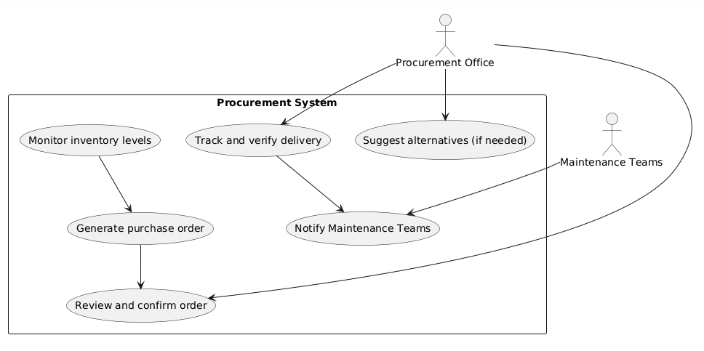

**Use Case 7: Cargo Services Management**

Use Case: Cargo Services Management  
Actors: Cargo Services, Airlines, Customers  
Description: Oversee and track cargo shipments, ensuring timely and accurate delivery information.  
Preconditions: Cargo shipment data is fully integrated into the system.

Main Flow:

1. Cargo Services enters cargo shipment details into the system.
   * *Example details:* Shipment ID, cargo type, weight, origin, destination, and scheduled pickup/drop-off times.
2. System updates real-time tracking information based on sensor data and logistics updates.
   * *Example details:* GPS coordinates, current transit status, estimated time of arrival, and any checkpoints passed.
3. System sends automated notifications to Airlines and Customers regarding the current shipment status.
   * *Example details:* Alerts indicating delays, confirmations of delivery milestones, and tracking report summaries.

Alternate Flows:

* If delays occur, System recalculates the delivery schedule, logs the reason for delay, and sends updated notifications to all stakeholders.

Postconditions:

* Cargo shipments are tracked effectively, with detailed logs ensuring that all stakeholders are informed of the shipment status at all times.

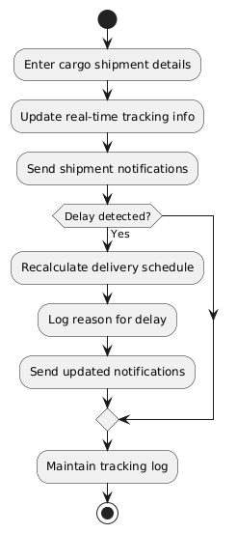

**Use Case 8: First Aid Services**

Use Case: First Aid Services  
Actors: First Aid Teams, Passengers  
Description: Provide immediate medical assistance during emergencies, track supply levels, and monitor response times.  
Preconditions: Emergency reporting systems and medical supply inventories are fully operational.

Main Flow:

1. Passenger or Airport Staff initiates a first aid request through the system interface.
   * *Example details:* Request ID, location (e.g., “Gate 15, Terminal 1”), description of the medical issue, and time of request.
2. System immediately notifies the First Aid Teams about the emergency.
   * *Example details:* Notification includes priority status and specific location details.
3. First Aid Teams respond promptly to the scene, provide necessary medical assistance, and update the system with treatment details.
   * *Example details:* Time of arrival, medical actions taken (e.g., “administered first aid, applied bandages”), and patient condition notes.
4. System logs the incident details and adjusts medical supply inventory as needed.
   * *Example details:* Updated counts of medical supplies (e.g., “gloves, bandages”), incident resolution time, and follow-up actions if required.

Alternate Flows:

* If immediate assistance isn’t available, System activates backup protocols, such as notifying additional emergency responders, and logs the delay with detailed reasons.

Postconditions:

* Medical support is rendered efficiently, with detailed records of the incident and inventory adjustments for future preparedness.

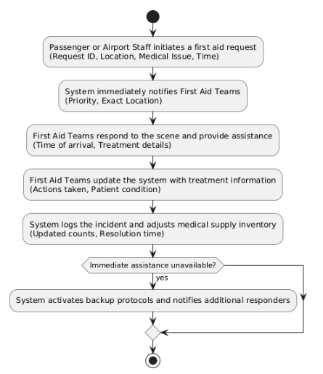

**Use Case 9: Runway Utilization Optimization**

| **Use Case** | **Runway Utilization Optimization** |
| --- | --- |
| **Actors** | Airport Operations Staff, Air Traffic Control |
| **Description** | Analyze flight and runway data to optimize runway assignments and maximize operational efficiency. |
| **Preconditions** | Up-to-date flight and runway status data are available. |
| **Main Flow** | 1. The system analyzes current flight schedules and runway availability.2. It recommends optimal runway assignments.3. Air Traffic Control reviews and implements the recommendations. |
| **Alternate Flows** | If a runway becomes unavailable, the system reassigns flights to alternative runways. |
| **Postconditions** | Runway usage is optimized and scheduling adjustments are communicated. |

**Use Case 10: Emergency Response Coordination**

| **Use Case** | **Emergency Response Coordination** |
| --- | --- |
| **Actors** | First Aid Teams, Security Personnel, Airport Operations Staff |
| **Description** | Dispatch and coordinate emergency services, track incident resolution. |
| **Preconditions** | Emergency is reported and communication channels are active. |
| **Main Flow** | 1. An emergency is reported through the system.2. Relevant emergency teams are notified.3. Response actions are coordinated and tracked until resolution. |
| **Alternate Flows** | If the initial response is insufficient, an escalation protocol is triggered. |
| **Postconditions** | The emergency is managed and all actions are logged. |

**Use Case 11: Airport Facility Inventory Management**

| **Use Case** | **Airport Facility Inventory Management** |
| --- | --- |
| **Actors** | Maintenance Teams, Procurement Office |
| **Description** | Monitor and manage inventory levels for airport facilities, including supplies and spare parts. |
| **Preconditions** | An updated inventory database and sensor integration are in place. |
| **Main Flow** | 1. The system continuously monitors inventory levels.2. Low stock alerts are generated.3. Purchase orders are initiated automatically. |
| **Alternate Flows** | In the event of a supply delay, alternative procurement options are activated. |
| **Postconditions** | Inventory is replenished in a timely manner. |

**Use Case 12: Weather Data Integration**

| **Use Case** | **Weather Data Integration** |
| --- | --- |
| **Actors** | Air Traffic Control, Airport Operations Staff |
| **Description** | Incorporate live weather data to adjust flight schedules and ensure safety protocols. |
| **Preconditions** | Access to reliable, real‑time weather data feeds. |
| **Main Flow** | 1. Weather data is received by the system.2. The impact on flight operations is analyzed.3. Scheduling adjustments and safety alerts are issued. |
| **Alternate Flows** | If weather data is temporarily unavailable, standard operational protocols are used. |

**Use Case 13: Ground Transportation Coordination**

| **Use Case** | **Ground Transportation Coordination** |
| --- | --- |
| **Actors** | Airport Operations Staff, Ground Handling Services |
| **Description** | Coordinate shuttle buses and other ground transport services to align with flight schedules. |
| **Preconditions** | Ground transport schedules and capacity information are available. |
| **Main Flow** | 1. The system schedules ground transport based on arriving/departing flights.2. Notifications are sent to ground services.3. Pick-ups and drop-offs are coordinated. |
| **Alternate Flows** | In case of delays, updated transport schedules are communicated promptly. |
| **Postconditions** | Ground transportation is synchronized with flight operations. |

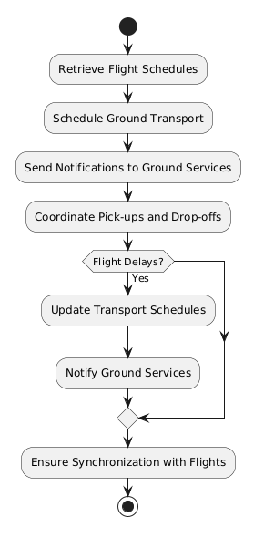

**Use Case 14: Vendor and Contractor Management**

| **Use Case** | **Vendor and Contractor Management** |
| --- | --- |
| **Actors** | Procurement Office, Airport Operations Staff |
| **Description** | Manage external service providers, track contracts, and monitor performance metrics. |
| **Preconditions** | A vendor database and contract management system are integrated. |
| **Main Flow** | 1. Vendor and contractor details are recorded in the system.2. Performance metrics and contract statuses are monitored.3. Alerts are issued for any compliance issues. |
| **Alternate Flows** | If performance criteria are not met, a review process is initiated. |
| **Postconditions** | Vendor contracts and performance are continuously managed. |

**Use Case 15: Environmental Monitoring**

| **Use Case** | **Environmental Monitoring** |
| --- | --- |
| **Actors** | Control Office, Airport Operations Staff |
| **Description** | Monitor environmental parameters such as noise, air quality, and emissions in real time. |
| **Preconditions** | Environmental sensors and data integration are active. |
| **Main Flow** | 1. Sensors collect environmental data.2. The system analyzes the data against regulatory thresholds.3. Alerts are triggered if values exceed safe limits. |
| **Alternate Flows** | If sensor data is unavailable, manual monitoring procedures are recommended. |
| **Postconditions** | Environmental conditions are maintained within set standards. |

**Use Case 16: Energy Management System Integration**

| **Use Case** | **Energy Management System Integration** |
| --- | --- |
| **Actors** | Maintenance Teams, Airport Operations Staff |
| **Description** | Monitor and control energy consumption across terminals (e.g., lighting, HVAC) to optimize efficiency. |
| **Preconditions** | Integration with existing energy management systems is established. |
| **Main Flow** | 1. Energy usage data is collected from connected systems.2. The system optimizes energy distribution.3. Reports on energy usage and savings are generated. |
| **Alternate Flows** | In the event of integration issues, manual override procedures are available. |
| **Postconditions** | Energy consumption is efficiently managed and reduced where possible. |

**Use Case 17: Flight Delay and Disruption Management**

| **Use Case** | **Flight Delay and Disruption Management** |
| --- | --- |
| **Actors** | Airport Operations Staff, Airlines, Passengers |
| **Description** | Detect and manage flight delays and disruptions by providing alternative scheduling and compensation options. |
| **Preconditions** | Real-time flight monitoring is active and disruptions are detected. |
| **Main Flow** | 1. The system identifies a delay/disruption.2. Affected parties are notified automatically.3. Alternative schedules or compensatory measures are offered. |
| **Alternate Flows** | If rescheduling is not feasible, additional support measures are initiated. |
| **Postconditions** | Flight disruptions are managed with minimal impact on operations and passenger experience. |

**Use Case 18: Digital Signage and Passenger Notification System**

| **Use Case** | **Digital Signage and Passenger Notification System** |  |
| --- | --- | --- |
| **Actors** | Airport Operations Staff, Passengers |  |
| **Description** | Manage dynamic displays and notifications across the airport to broadcast flight updates and alerts. |  |
| **Preconditions** | Digital signage and notification systems are operational. |  |
| **Main Flow** | 1. The system pushes real-time updates to digital displays.2. Notifications are sent to mobile devices where applicable.3. Stakeholders receive consistent updates across channels. |  |
| **Alternate Flows** | In case of signage failure, notifications are rerouted to mobile apps and public announcement systems. |  |
| **Postconditions** | Passengers and staff remain informed through multiple channels. |  |

**Passenger Experience System (PES)**

**Use Case 19: Flight Information and Updates**

| **Use Case** | **Flight Information and Updates** |
| --- | --- |
| **Actors** | Passengers, Airlines |
| **Description** | Provide real-time flight status, gate details, and schedule updates via mobile or kiosk interfaces. |
| **Preconditions** | Flight data is synchronized with the system. |
| **Main Flow** | 1. Passenger queries flight status.2. The system retrieves current flight data.3. Real-time updates are displayed. |
| **Alternate Flows** | In the event of delays, alternative flight options and notifications are provided. |
| **Postconditions** | Passengers receive accurate and timely flight information. |

**Use Case 20: Self-Service Check-in and Baggage Drop**

| **Use Case** | **Self-Service Check-in and Baggage Drop** |
| --- | --- |
| **Actors** | Passengers, Airlines |
| **Description** | Enable passengers to complete check-in, print boarding passes, and drop off baggage using self-service kiosks. |
| **Preconditions** | Passenger booking details are verified and kiosks are fully functional. |
| **Main Flow** | 1. Passenger enters booking information.2. The system verifies details and prints a boarding pass.3. Baggage is dropped off at the kiosk. |
| **Alternate Flows** | If verification fails, manual assistance is requested. |
| **Postconditions** | Check-in and baggage drop are completed seamlessly. |

**Use Case 21: Retail and Dining Services**

| **Use Case** | **Retail and Dining Services** |
| --- | --- |
| **Actors** | Passengers, Airport Retailers |
| **Description** | Allow passengers to browse and purchase products or dining options available at the airport. |
| **Preconditions** | Retail and dining systems are integrated with inventory and payment processing. |
| **Main Flow** | 1. Passenger browses retail/dining options.2. The system processes the transaction.3. Confirmation is provided to the passenger. |
| **Alternate Flows** | If payment issues arise, alternative payment methods are offered. |
| **Postconditions** | The transaction is successfully completed. |

**Use Case 22: Self-Service Baggage Drop and Tag Printing**

| **Use Case** | **Self-Service Baggage Drop and Tag Printing** |
| --- | --- |
| **Actors** | Passengers, Airlines |
| **Description** | Extend kiosk functionality to print baggage tags and facilitate baggage drop-off. |
| **Preconditions** | Kiosks are equipped with printing hardware and connected to the baggage system. |
| **Main Flow** | 1. Passenger selects the baggage drop option.2. The system prints baggage tags.3. Passenger attaches the tags and drops off the baggage. |
| **Alternate Flows** | If printing fails, staff assistance is provided. |
| **Postconditions** | Baggage is properly tagged and queued for processing. |

**Use Case 23: Personalized Passenger Itinerary and Travel Assistance**

| **Use Case** | **Personalized Passenger Itinerary and Travel Assistance** |
| --- | --- |
| **Actors** | Passengers, Airlines, Customer Service Teams |
| **Description** | Generate custom travel itineraries incorporating flight details, transfers, and ancillary services. |
| **Preconditions** | Passenger profile and travel preference data are available. |
| **Main Flow** | 1. Passenger enters travel preferences.2. The system compiles a personalized itinerary.3. Additional assistance options are offered. |
| **Alternate Flows** | If itinerary generation fails, customer service intervenes manually. |
| **Postconditions** | A tailored travel plan is delivered to the passenger. |

**Use Case 24: Interactive Wayfinding and Terminal Navigation**

| **Use Case** | **Interactive Wayfinding and Terminal Navigation** |
| --- | --- |
| **Actors** | Passengers |
| **Description** | Provide interactive maps and navigation routes within the terminal to guide passengers to gates, lounges, etc. |
| **Preconditions** | Updated terminal maps and location services are active. |
| **Main Flow** | 1. Passenger selects a destination.2. The system generates a navigation route.3. Real-time adjustments are made if necessary. |
| **Alternate Flows** | If real-time connectivity is lost, offline maps are provided. |
| **Postconditions** | Passengers reach their selected destination efficiently. |

**Use Case 25: Real-Time Passenger Feedback Collection**

| **Use Case** | **Real-Time Passenger Feedback Collection** |
| --- | --- |
| **Actors** | Passengers, Customer Service Teams |
| **Description** | Collect immediate feedback regarding airport services and facilities via kiosks or mobile devices. |
| **Preconditions** | Feedback interfaces are integrated and active. |
| **Main Flow** | 1. Passenger submits feedback.2. The system logs and analyzes the response.3. Alerts are generated if needed for immediate action. |
| **Alternate Flows** | If the digital system is down, paper forms are used temporarily. |
| **Postconditions** | Feedback is gathered and used to improve services. |

**Use Case 26: Digital Advertisement and Promotion Display System**

| **Use Case** | **Digital Advertisement and Promotion Display System** |
| --- | --- |
| **Actors** | Passengers, Airport Retailers |
| **Description** | Display targeted ads and promotional content based on passenger profiles and real‑time context. |
| **Preconditions** | Digital signage and advertisement databases are integrated. |
| **Main Flow** | 1. The system selects appropriate advertisements.2. Content is displayed on digital screens and/or mobile apps.3. Engagement metrics are recorded. |
| **Alternate Flows** | If targeted ads fail to load, default ads are shown. |
| **Postconditions** | Passengers view relevant promotional content. |

**Use Case 27: Lost and Found Reporting System**

| **Use Case** | **Lost and Found Reporting System** |
| --- | --- |
| **Actors** | Passengers, Customer Service Teams |
| **Description** | Allow passengers to report lost items and track the status of found items via the system. |
| **Preconditions** | Lost and found modules are active and connected to the central database. |
| **Main Flow** | 1. Passenger files a report for a lost item.2. The system logs the report and assigns a tracking number.3. Updates are provided as the item is recovered. |
| **Alternate Flows** | If the digital system is unavailable, manual logging procedures are used. |
| **Postconditions** | Lost items are tracked and retrieval processes are initiated. |

**Use Case 28: Special Assistance Request Handling**

| **Use Case** | **Special Assistance Request Handling** |
| --- | --- |
| **Actors** | Passengers, Customer Service Teams |
| **Description** | Facilitate requests for special assistance (e.g., mobility support) ensuring prompt response. |
| **Preconditions** | The assistance module is operational and staff are available. |
| **Main Flow** | 1. Passenger submits a special assistance request.2. The system notifies the appropriate support team.3. Assistance is provided and tracked. |
| **Alternate Flows** | If no support is immediately available, alternative contact information is provided. |
| **Postconditions** | The passenger receives the requested assistance in a timely manner. |

**Use Case 29: Lounge and Facility Reservation System**

| **Use Case** | **Lounge and Facility Reservation System** |
| --- | --- |
| **Actors** | Passengers, Airport Operations Staff, Customer Service Teams |
| **Description** | Allow premium passengers to reserve lounges or other airport facilities via an integrated reservation system. |
| **Preconditions** | Facility availability data is current and reservation software is integrated. |
| **Main Flow** | 1. Passenger selects a reservation option.2. The system checks availability and confirms booking.3. Confirmation details are communicated. |
| **Alternate Flows** | If the preferred facility is unavailable, alternative options are suggested. |
| **Postconditions** | Reservation is completed and logged in the system. |

**Use Case 30: Integrated Passenger Support System**

| **Use Case** | **Integrated Passenger Support System** |
| --- | --- |
| **Actors** | Passengers, Customer Service Teams, IT Support Teams |
| **Description** | Provide a unified interface that aggregates real‑time flight updates, feedback, assistance requests, and other self‑service features for a seamless passenger experience. |
| **Preconditions** | All individual PES modules are online and integrated into the support portal. |
| **Main Flow** | 1. Passenger accesses the integrated support portal.2. The system aggregates data from flight, feedback, and service modules.3. A consolidated dashboard is provided. |
| **Alternate Flows** | If one module fails, individual functions remain accessible independently. |
| **Postconditions** | Passengers experience a seamless, all‑in‑one support system. |